**LEVEL ONE**

**Game description**

* the overall game`s purpose is entertain and teach the interactive player about history
* specifically this level one is aimed to express the event that happened in the place called halai And a character has been created for fictional purpose due to inconsistent win over our enemy for the interactive player to progress through the game until the end.
* interactive player start the game after listing to the narrated video about the war between Major Toselli and bahta hagos also over all history of adwa and this narration was needed to show the history relevance behind game .
* the first event to happen is the fictional character finding a letter from wounded man and by this scene we tried to show what was the convince way to transmit massage at that time, even though the Italians and Ethiopian’s used to communicate using a telegram the Ethiopian rebels don`t have that privilege and we tried to show what kind of typography were used at the time.

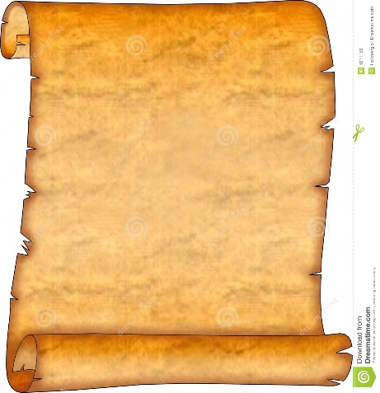after reading the message the player start his journey to halai. At this moment a map would appear on the screen and our interactive player should properly read the map`s instruction, at this point our aim is to engage our player to be familiar with those basic components and move forward in the game

* the next step would be reading the map and moving to the lake kurma at these point the aim of the game focus is more on showing you what the environment would looking like which is very drastic place and the task where the player had to drinking water is to create a challenge to move forward in the game.
* the last task would be finding bahta hagos and this point the history relevance comes in play again to show that we lost the first rebellion attack against our enemy though our player had to move on to the next level so that the fictional character we created would get this token from bahta at his last moment and finish the level

**Design Goal**

The game has two main input

**1.** design or graphic input

* Creating the main character

(Doing this will include considering what he should looks like regarding physical appearance, hair style clothing and soon….)

* Try to imitate the historic event participants like bahta hagos in the narration

(Since there is a photo of bahta hagos the task would be creating the character resembling what how he should look like)

* Designing what the environment would look like
  + What the color intensity should look like
  + How the wind should sound
* Pictures of head model ,hair style and clothing

**2.** Logical input

* Gathering all the design from the design team

(Incorporating the design teams input to the game structure)

* Creating sequential order for the game script
* Managing the players restricted move

(Since the player is moving in the prescript path and making the moves with a few choice everything is coded accordingly)

**Narration video**

There are two narration in level one

1. The first is the fact the player find a wounded solider on the road and get the letter from him

* When he approach the wounded soldier the game starts the narration and the letter will be shown at the same time it`s narrated.

2. The second narration begins when the fictional character finds bahta hagos laying down at his last breath

* A picture of bahta will laying down taking to the fictional solider and telling him to take the sword as a token to Ras mengesha

**Game mechanics**

**CORE GAME PLAY**

**HAPPENINGS IN THIS LEVEL**

* Player finds a wounded soldier with a message and reads it.
* Player decides to go to Halai (Bahta Hagos's location).Player knows Bahta's location from the map popping in a corner.
* Player gets to water.
* Health deterioration (Player's health deteriorates due to the weather).
* Animations (in the beginning middle and end of the game).

Checkpoints

1. Getting message from wounded soldier.

2. Getting to the water source.

3. Finding Déjà mach Bahta Hagos.

**HOW THE PLAYER PLAYS THE GAME**

This is the first level of the game; in this level the player plays the game using basic controls and some interaction controls mentioned below.

* Action key to perform reading. (Player finds a wounded soldier with a message and reads it.)
* Movement control to navigate through the map. (Player decides to go to Halai (Bahta Hagos's location).Player knows Bahta's location from map popping in a corner.)
* Action key to drink water. (Player gets to water.)
* Action key to receive sword.( can also be animated)

**Game Flow Diagram**

NO

Am I notified?

Yes

Use the Map to head to Lake KURMA before health deteriorates

The Game terminates

Am I dead?

Yes

NO

Drink water from the lake

Approach Bahta Hagos

No

The game terminates

YES

Receive a sword from Bahta Hagos

**Game physics and statistics**

The physics and statistics on this level are described as follows

1. Jogging: this is a basic action of jogging around the arena. This enables the player to get to the destination they want with small time; thus avoiding health deterioration due to bad weather.
2. Sprint: this action enables the player to sprint forward fast. This makes it even easier and convenient for the player to navigate around the map and find available resources (water in this level).
3. Crouching: in this level even though the player may not be required to crouch; it helps the player to pass through barriers when navigating the map.

**Architectural Design**

**Graphical representation**

SOUND

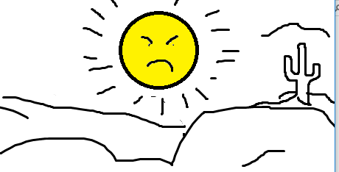

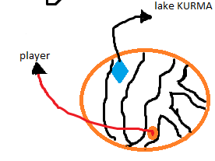 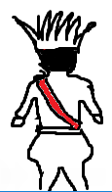

Description of architecture views

**Environment**: the environment will look like a desert location since it is near Dalol (the lowest level on earth). The environment makes it hard for the player to survive unless there is a water to drink for the player.

**Player**: the player stars with a drained health condition. And he is exhausted with the harsh condition of the environment.

**Challenge**: the challenge in this level is not a human enemy, but a challenge of getting over the environmental challenges. The other challenge would be the challenge of getting to Bahta hagos which will be the end of the level.

**Sound** : some of the sound include crow sound in the desert, and wind or a thunder sound around the desert and the likes.

The sketch for the player, the challenge and the environment will look like the figure below:

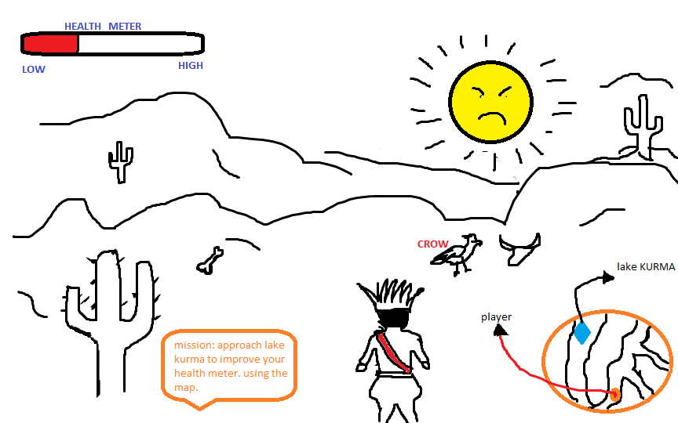

**HIGH LEVEL AND DETAILED DESIGN**

**LOGIC FUNCTIONS**

**Player**

Most of the player’s script is implemented as an event triggered actions and this events are taken as key stroke from keyboard and what the player wants to do is given to the player with this functionality.

1. While (1)
2. **If** action from keyboard == “w”
3. Player moves forward;
4. else **If** action from keyboard == “s”
5. Player moves backward;
6. else **If** action from keyboard == “a”
7. Player moves left;
8. else **If** action from keyboard == “d”
9. Player moves right;
10. else **If** action from keyboard == “space”
11. Player jumps;
12. else **If** action from keyboard == “LShift”
13. Player advances faster in the direction the player is facing;
14. **If** action from keyboard == “c”
15. Player crouch irrespective of the direction faced;
16. While (player is in the environment)
17. Health decreases in proportion to time spent in the environment
18. While (player gets water)

Health increases in proportion water drunk by the player

**SECONDARY PLAYER**

1. WHILE (1)
2. TRACK PLAYER POSTION
3. FOLLW THE PLAYER
4. ATTCKE ENEMIS IN RANGE

**Environment**

Since the in environment holds every component in these game the duty of checking the position and activating enemies is given to it.

So it becomes

1. Check position change in player //first move of player (for the first time only)
2. Activate notification
3. Check if notification is destroyed
4. **If** destroyed save this point as last checkpoint.
5. **While (1)** // always do this as loop
6. Check the distance between enemies’ and the player

**If** in range activate enemies

1. Check the distance between player and sound source

**If** in range activate the sound source

1. Check the number of remaining enemies
2. **If** none

10. Display end of level notification

11. Terminate the level.

**Enemies**

1. **while (1)**
2. check player position
3. Approach player position
4. **If** in long range
5. Fire to the player // to the player position
6. **Else If** in short range
7. Perform combat action
8. **If** fired to self
9. Degrade health status
10. Destroy.

**Map**

1. While **(1)**
2. Fix map to the top wright corner
3. Track player
4. Plot the player
5. Track the enemies
6. Plot enemies